## Week4 Assignment 1

### DEY, Sankha

#### Missing Data

# message=FALSE done before last knit  
library(tidyverse)  
library(VIM)  
library(mice)

grades <- read_csv("class-grades.csv")

## Parsed with column specification:  
## cols(  
## Prefix = col_double(),  
## Assignment = col_double(),  
## Tutorial = col_double(),  
## Midterm = col_double(),  
## TakeHome = col_double(),  
## Final = col_double()  
## )

summary(grades)

## Prefix Assignment Tutorial Midterm   
## Min. :4.000 Min. : 28.14 Min. : 34.09 Min. : 28.12   
## 1st Qu.:7.000 1st Qu.: 80.88 1st Qu.: 83.93 1st Qu.: 52.50   
## Median :8.000 Median : 89.94 Median : 93.37 Median : 69.38   
## Mean :7.313 Mean : 85.49 Mean : 89.79 Mean : 67.70   
## 3rd Qu.:8.000 3rd Qu.: 95.00 3rd Qu.:100.56 3rd Qu.: 81.56   
## Max. :8.000 Max. :100.83 Max. :112.58 Max. :110.00   
## NA's :1 NA's :3   
## TakeHome Final   
## Min. : 16.91 Min. : 28.06   
## 1st Qu.: 69.91 1st Qu.: 52.91   
## Median : 88.42 Median : 66.11   
## Mean : 81.12 Mean : 68.23   
## 3rd Qu.: 99.07 3rd Qu.: 83.61   
## Max. :108.89 Max. :108.89   
## NA's :3 NA's :4

#### Task 1

About 1% data missing in Tutorial, 3% data missing in Midterm and TakeHome and 4% missing at Final variable. These are the four variables (Tutorial, Midterm, TakeHome and Final) where data is missing.

#### Task 2

vim_plot = aggr(grades, numbers = TRUE, prop = c(TRUE, FALSE),cex.axis=.7)

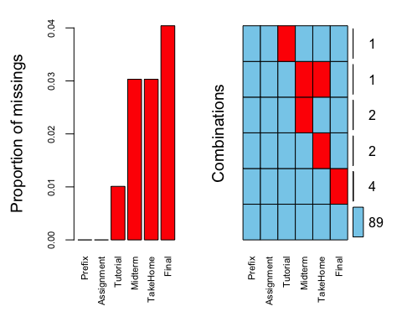

These missingness are kind of random.There is only one student who is missing both midterm and TakeHome data.

#### Task 3

grades_row = grades %>% drop_na()  
str(grades_row)

## Classes 'tbl_df', 'tbl' and 'data.frame': 89 obs. of 6 variables:  
## $ Prefix : num 5 8 8 7 8 7 8 8 7 7 ...  
## $ Assignment: num 57.1 95 83.7 81.2 91.3 ...  
## $ Tutorial : num 34.1 105.5 83.2 96.1 93.6 ...  
## $ Midterm : num 64.4 67.5 30 49.4 95 ...  
## $ TakeHome : num 51.5 99.1 63.1 105.9 107.4 ...  
## $ Final : num 52.5 68.3 48.9 80.6 73.9 ...

10 rows deleted. So, 89 rows remain in the new datafeame.

#### Task 4

grades_column = grades %>% dplyr::select(Prefix,Assignment)  
str(grades_column)

## Classes 'spec_tbl_df', 'tbl_df', 'tbl' and 'data.frame': 99 obs. of 2 variables:  
## $ Prefix : num 5 8 8 7 8 7 8 7 8 7 ...  
## $ Assignment: num 57.1 95 83.7 81.2 91.3 ...  
## - attr(*, "spec")=  
## .. cols(  
## .. Prefix = col_double(),  
## .. Assignment = col_double(),  
## .. Tutorial = col_double(),  
## .. Midterm = col_double(),  
## .. TakeHome = col_double(),  
## .. Final = col_double()  
## .. )

Just 2 columns remain in the new data frame.

#### Task 5

Task 3 (removing rows for missing data) seems to be preferable because we miss less amount of data in this case. Removing columns with missing data is not preferable in this example, because we are missing a large amount of data by that process. Our overall purpose of analyzing the data won’t be fulfilled if we miss such large amount of data.

#### Task 6

grades_imp = mice(grades, m=1, method = "pmm", seed = 12345)

##   
## iter imp variable  
## 1 1 Tutorial Midterm TakeHome Final  
## 2 1 Tutorial Midterm TakeHome Final  
## 3 1 Tutorial Midterm TakeHome Final  
## 4 1 Tutorial Midterm TakeHome Final  
## 5 1 Tutorial Midterm TakeHome Final

#in line above: m=1 -> runs one imputation, seed sets the random number seed to get repeatable results  
summary(grades_imp)

## Class: mids  
## Number of multiple imputations: 1   
## Imputation methods:  
## Prefix Assignment Tutorial Midterm TakeHome Final   
## "" "" "pmm" "pmm" "pmm" "pmm"   
## PredictorMatrix:  
## Prefix Assignment Tutorial Midterm TakeHome Final  
## Prefix 0 1 1 1 1 1  
## Assignment 1 0 1 1 1 1  
## Tutorial 1 1 0 1 1 1  
## Midterm 1 1 1 0 1 1  
## TakeHome 1 1 1 1 0 1  
## Final 1 1 1 1 1 0

densityplot(grades_imp)

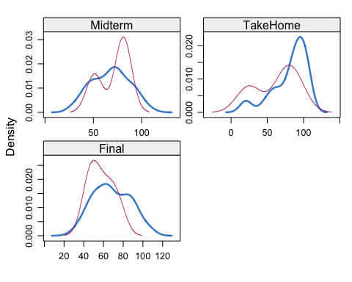

#red imputed, blue original, only shows density plots when more than 1 value the variable was imputed  
#note that the density plots are fairly uninteresting given the small amount of missing data  
grades_complete = complete(grades_imp)  
summary(grades_complete)

## Prefix Assignment Tutorial Midterm   
## Min. :4.000 Min. : 28.14 Min. : 34.09 Min. : 28.12   
## 1st Qu.:7.000 1st Qu.: 80.88 1st Qu.: 84.69 1st Qu.: 52.50   
## Median :8.000 Median : 89.94 Median : 93.10 Median : 69.38   
## Mean :7.313 Mean : 85.49 Mean : 89.76 Mean : 67.80   
## 3rd Qu.:8.000 3rd Qu.: 95.00 3rd Qu.:100.55 3rd Qu.: 81.88   
## Max. :8.000 Max. :100.83 Max. :112.58 Max. :110.00   
## TakeHome Final   
## Min. : 16.91 Min. : 28.06   
## 1st Qu.: 67.96 1st Qu.: 52.09   
## Median : 87.96 Median : 65.56   
## Mean : 80.54 Mean : 67.81   
## 3rd Qu.: 98.42 3rd Qu.: 83.19   
## Max. :108.89 Max. :108.89

#### Task 7:

Briefly discuss potential issues that could be encountered when working with missing data. Describe situations where imputation may not be advisable.

**Answer:** Missing data can reduce the statistical power of a study and can produce biased estimates, leading to invalid conclusions. Missing data can also reduce the representativeness of the samples. Overall, the cocnclusions of statistical analysis may not be accurate.  
There are few situations when imputations are not advisable - 1. When a large chunk of data in a particular variable is missing. Suppose 95% data are missing and guesing a value with remaining 5% doesn’t make much sense. Column-wise deletion may help there. 2. Similarly, if one observation has data points missing across multiple variables, then doing multiple imputations across missing variables is not advisable. Row-wise deletion is preferrable at that scenario.